### Semester Two Examination, 2017

### Question/Answer booklet

# MATHEMATICS

**SPECIALIST**

**UNITS 1 AND 2**

## Section One:

## Calculator-free

Name

Teacher’s name

## Time allowed for this section

Reading time before commencing work: five minutes

Working time: fifty minutes

## Materials required/recommended for this section

***To be provided by the supervisor***

This Question/Answer booklet

Formula sheet

***To be provided by the candidate***

Standard items: pens (blue/black preferred), pencils (including coloured), sharpener, correction fluid/tape, eraser, ruler, highlighters

Special items: nil

## Important note to candidates

No other items may be taken into the examination room. It is **your** responsibility to ensure that you do not have any unauthorised material. If you have any unauthorised material with you, hand it to the supervisor **before** reading any further.

## Structure of this paper

|  |  |  |  |  |  |
| --- | --- | --- | --- | --- | --- |
| Section | Number of questions available | Number of questions to be answered | Working  time (minutes) | Marks available | Percentage of examination |
| Section One:  Calculator-free | 8 | 8 | 50 | 48 | 35 |
| Section Two:  Calculator-assumed | 13 | 13 | 100 | 98 | 65 |
|  | | |  | **Total** | 100 |

|  |  |  |
| --- | --- | --- |
| Markers use only | | |
| Question | Maximum | Mark |
| 1 | 6 |  |
| 2 | 4 |  |
| 3 | 6 |  |
| 4 | 9 |  |
| 5 | 8 |  |
| 6 | 8 |  |
| 7 | 6 |  |
| 8 | 5 |  |
| S1 Total | 48 |  |
| S1 Wt (×0.6731) | 35% |  |
| S2 Wt | 65% |  |
| Total | 100% |  |

## Instructions to candidates

1. The rules for the conduct of examinations are detailed in the school handbook. Sitting this examination implies that you agree to abide by these rules.

2. Write your answers in this Question/Answer booklet.

3. You must be careful to confine your response to the specific question asked and to follow any instructions that are specified to a particular question.

4. Additional working space pages at the end of this Question/Answer booklet are for planning or continuing an answer. If you use these pages, indicate at the original answer, the page number it is planned/continued on and write the question number being planned/continued on the additional working space page.

5. Show all your working clearly. Your working should be in sufficient detail to allow your answers to be checked readily and for marks to be awarded for reasoning. Incorrect answers given without supporting reasoning cannot be allocated any marks. For any question or part question worth more than two marks, valid working or justification is required to receive full marks. If you repeat any question, ensure that you cancel the answer you do not wish to have marked.

6. It is recommended that you do not use pencil, except in diagrams.

7. The Formula sheet is not to be handed in with your Question/Answer booklet.

Section One: Calculator-free 35% (48 Marks)

This section has**eight (****8)** questions. Answer **all** questions. Write your answers in the spaces provided.

Working time: 50 minutes.

Question 1 (6 marks)

(a) Determine the values of the real constants $b$ and $c$ if $z=1+3i$ is a solution of the equation $z^{2}+bz+c=0$. (3 marks)

(b) Express the real quadratic polynomial $z^{2}-4z+8$ as a product of its linear factors.

(3 marks)

Question 2 (4 marks)

The complex numbers $u$ and $v$ are shown in the complex plane below.

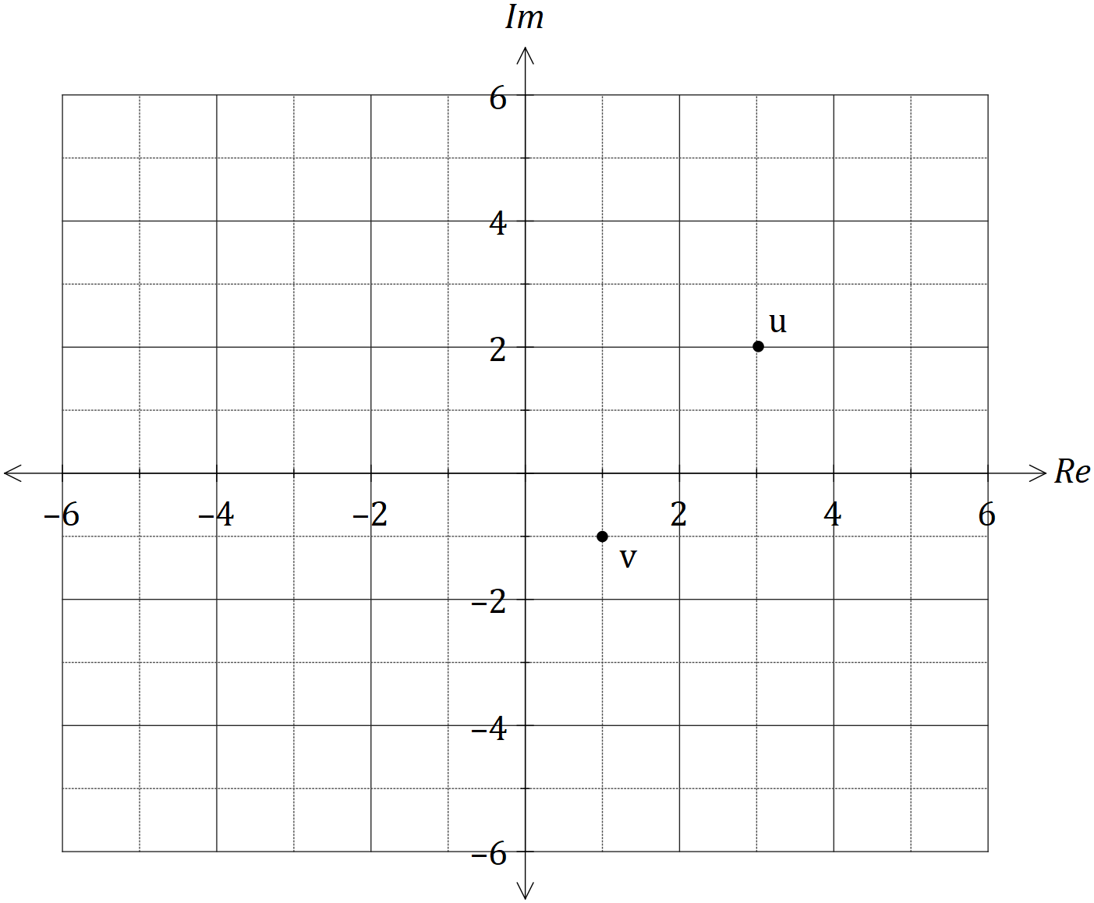

Plot and label the following complex numbers:

(a) $z_{1}=u-v$. (1 mark)

(b) $z_{2}=2v+u$. (1 mark)

(c) $z_{3}=\overline{u}$. (1 mark)

(d) $z_{4}=\overline{u}-\overline{v}-\overline{u-v}$. (1 mark)

Question 3 (6 marks)

(a) A set of real numbers is given by $\left\{\sqrt{2}, 3.\overline{14}, π, \sqrt[3]{14} \right\}$. Clearly show that one of the numbers in the set is rational. (3 marks)

(b) Show that if $n$ is one more than a multiple of three, then $n^{2}$ will also be one more than a multiple of three, where $n∈Z$. (3 marks)

Question 4 (9 marks)

Let $A=\left[\begin{matrix}8 & 3 \\ 5 & 2\end{matrix}\right]$ and $B=\left[\begin{matrix}6 & 11 \\ -3 & 7\end{matrix}\right]$.

(a) Determine

(i) $3A-B$. (2 marks)

(ii) $BA$. (2 marks)

(iii) $A^{-1}$. (2 marks)

(b) Use a matrix method to solve the system of equations $8x+3y=10$ and $5x+2y=7$.

(3 marks)

Question 5 (4 marks)

Prove that $\begin{matrix}1+\cos{x} \\ \overline{\sin{x}+\tan{x}}\end{matrix}=\cot{x}$. (4 marks)

Question 6 (8 marks)

Relative to the origin $O$, the points $A$, $B$ and $C$ have position vectors $a=5i-6j$, $b=i-3j$ and $c=-8i+15j$ respectively.

(a) Determine in Cartesian form

(i) the vector $\vec{AB}$. (1 mark)

(ii) a vector $d$, parallel to $\vec{AB}$ and of magnitude $\sqrt{5}$. (3 marks)

(b) If $c=λa+μb$, determine the values of the constants $λ$ and $μ$. (4 marks)

Question 7 (6 marks)

Let $z_{1}$ and $z_{2}$ be complex numbers such that $3z_{1}-2z_{2}=7$ and $z_{1}+iz_{2}=3i$.

Determine $z_{1}$ and $z_{2}$ in the form $z=a+bi$, where $a, b∈Z$.

Question 8 (5 marks)

Cyclic quadrilateral $ABCD$ has diagonals $AC$ and $BD$ that intersect at $M$. Given that $BM=12$ cm, $DM=7$ cm and $AC=20$ cm, determine the largest possible length of $AM$.

Additional working space

Question number: _________